

Project Report on

**XY- Pen Plotter**

***In partial fulfilment of the requirements for the degree of***

**Master of Engineering in**

**Mechatronics and Robotics**

Under the subject of:

**Workshop Mechatronics**

Submitted By:

|  |  |
| --- | --- |
| Rajat Joshi | 315511 |
| Sagar Patil | 315501 |
| Prabhat Gaikwad | 315007 |
| Vinit Devchandani | 315516 |
| Hikmaddin Abishov | 316029 |

Department of Mechanical Engineering

Schmalkalden University of Applied Sciences

Blechhammer 9, 98574 Schmalkalden

July 2023

**CERTIFICATE**

This is to certify that the project titled “**2D Pen plotter**” submitted by **RAJAT JOSHI: 315511** **SAGAR PATIL: 315501** **PRABHAT GAIKWAD: 315007** **VINIT DEVCHANDANI: 315516; HIKMADDIN ABISHOV: 316029;** to the Mechanical Engineering Department of Schmalkalden University of Applied Sciences, in partial fulfillment of the requirements for the award of the degree of Master of Engineering in Mechatronics and Robotics is a record of our own work.

To the best of my knowledge, this report has not been submitted to any other University or Institute for award of any degree.

|  |  |  |  |  |
| --- | --- | --- | --- | --- |
| **Rajat**  **Joshi** | **Sagar**  **Patil** | **Prabhat**  **Gaikwad** | **Vinit Devchandani** | **Hikmaddin Abishov** |
| 315511 | 315501 | 315007 | 315516 | 316029 |

This is to certify that the statements made by the candidate are correct to the best of our knowledge and belief. It is further understood that by this certificate the undersigned do not endorse or approve any statement made, opinion expressed or conclusion drawn herein, but approve the report only for the purpose for which it is submitted

**Countersigned:**

|  |  |
| --- | --- |
| **Prof. Dr.-Ing. Stefan Roth,**  Professur Produktentwicklung / Konstruktion  Angewandte Kunststofftechnik (AKT), Fakultät Maschinenbau, Hochschule Schmalkalden,  Blechhammer 9, 98574 Schmalkalden | **Prof. Dr.-Ing. Silvio Bachmann,**  Assistant Professor & Coordinator, Fakultät Elektrotechnik, Hochschule Schmalkalden,  Blechhammer 9, 98574 Schmalkalden |

**ACKNOWLEDGEMENT**

We would like to put forth our regardful thanks to all those who had helped us in guiding us to get the most out of this golden opportunity to learn the most during this project on 2D Pen plotter.

We pay our special thanks to **Prof. Dr.-Ing. Stefan Roth, Prof. Dr.-Ing. Silvio Bachmann, Mr. Joshua Voll** & **Mr. Samuel Werner,** who provided excellent guidance as well as they had always been supporting and helpful.

We also put forth our special thanks to all the concerned persons who have enabled us to have an opportunity to work at the prestigious organization.

Thankful,

**Rajat Joshi (315511) Sagar Patil (315501) Prabhat Gaikwad (315007) Vinit Devchandani (315516) Hikmaddin Abishov(316029)**

**Table of Contents**

1. Introduction 7

1.1 Objectives 7

2. Project Goals and Project Planning 8

2.1 Project Goals and Objectives 8

2.2 Organisation Chart 8

2.3 Project Timeline 9

2.4 Development of documentation according to V-model 10

2.5 Morphological Chart: 11

3. Design Stage 12

3.1 Component Selection 12

3.2 Electrical Design 14

3.3 Mechanical CAD Design 15

3.4 Key Design Decision 17

4. Development and Fabrication Stage 20

5. Testing and Iteration 22

5.1 Testing Procedure: 22

5.2 Design Iteration: 22

6. Conclusion and Acknowledgements 27

6.1 Bill of Materials: 27

6.2 Future Scope: 30

Figure 1.1 Pen Plotter 7

Figure 3.1 Organisation Chart 8

Figure 4.2 ESP32 Board 13

Figure 5.2 Test piece 21

# Introduction

## Objectives

We are pleased to present the project report of our pen plotter, a remarkable undertaking by our group. With a clear aim in mind, we set out to design and develop a pen plotter capable of creating intricate drawings, with a specific focus on the renowned Nikolaus Haus. This project report provides a detailed account of our journey, outlining the design process, implementation strategies, testing procedures, and the successful realization of our pen plotter project.

Figure 1.1 Pen Plotter

The Nikolaus Haus, with its complex architectural details and artistic significance, presented us with an exciting challenge. Our objective was only to create a pen plotter capable of accurately reproducing the Nikolaus Haus.

The design phase encompassed a meticulous exploration of hardware, software, and mechanical components. We carefully selected the appropriate motors, sensors, and control mechanisms to achieve the desired accuracy and control. Our software development involved designing and implementing complex algorithms capable of interpreting the drawing sequence and transforming them into precise pen movements.

Testing and evaluation played a pivotal role in validating the performance of our pen plotter. We subjected the system to a series of rigorous tests, measuring its accuracy, speed, and overall capability to recreate the Nikolaus Haus. By meticulously analysing the test results and making iterative improvements, we ensured that our pen plotter delivered exceptional results, capturing the essence of the Nikolaus Haus in every stroke.

This project report provides an in-depth account of our journey, detailing the design process, implementation strategies, testing methodologies, and the final outcome of our pen plotter project. It is a testament to our passion for innovation, dedication to precision, and appreciation for the architectural marvels that inspire us. We hope that our work not only contributes to the field of pen plotting but also sparks further exploration and creativity in the world of architectural representation and artistic expression.

# Project Goals and Project Planning

## Project Goals and Objectives

Figure 1.2 Nikolaus Haus

The primary objective of the project is to design and develop a pen plotter by integrating all the available components. These components will be responsible for controlling the movement of the pen and ensuring accurate plotting on paper.

The project team will design, fabricate and assemble the pen plotter, program the control system, and create an intuitive user interface. The following tasks will be performed:

* Identifying user requirement and then creating Technical & Design specification.
* Implementing H/W, S/W, Electrical & Mechanical CAD Design.
* Developing a user interface to control the movement of the pen.
* Testing and calibrating the pen plotter for optimal performance.
* Demonstrating the functionality and output of the pen plotter through plotted designs of **Nikolaus Haus**.

## Organisation Chart

Figure 3.1 Organisation Chart

## Project Timeline

The project timeline for the pen plotter includes phases such as research and design, component acquisition, prototyping, testing, and final implementation, spanning a period of more than three months.

Table 2.1 Project Timeline

|  |  |  |  |
| --- | --- | --- | --- |
| Phase | Tasks | Days | Start Date |
| **Idea Phase** | | 7 | 17.04.23 |
|  | Market Research | 2 |  |
|  | Benchmarking models of seniors in lab | 1 |
|  | Brainstorming for new features integration | 3 |
|  | Set User Requirement | 1 |
|  | Idea phase finished, Deliverable user requirement | 0 |
| Project Planning | | 6 | 24.04.23 |
|  | Budget and Resource Planning | 1 |  |
| Set-Up Project Team | 1 |
| Technical Specification | 2 |
| Design Specification | 2 |
| Project Planning Phase Complete | 0 |
| Development Phase | | 34 | 02.05.23 |
|  | Concept Development | 2 |  |
| Electrical Design | 2 |
| Software Design | 18 |
| Mechanical / CAD Design | 12 |
| CAD Model & Electrical Circuit Diagram Ready | 0 |
| Prototyping & Fabrication | | 14 | 02.06.23 |
|  | 3D printing of test piece for fitment | 2 |  |
| Test piece printing and checking | 1 |
| 3D printing of plastic parts | 6 |
| Assembly | 2 |
| Electrical Wiring | 3 |
| Prototype Complete | 0 |
| Testing and calibration | | 17 | 16.06.23 |
|  | Programming and Troubleshooting | 6 |  |
| X and Y Axis calibration | 3 |
| Testing drawing performance and tuning PID | 4 |
| Verification Protocol & report | 2 |
| Validation Protocol & report | 2 |
| Testing and calibration complete | 0 |
| Documentation | | 5 | 10.07.23 |
|  | Project Presentation | 5 |  |
| Project Dossier | 5 |
| Bill of material | 1 |
| Documentation Complete | 0 |

## Development of documentation according to V-model

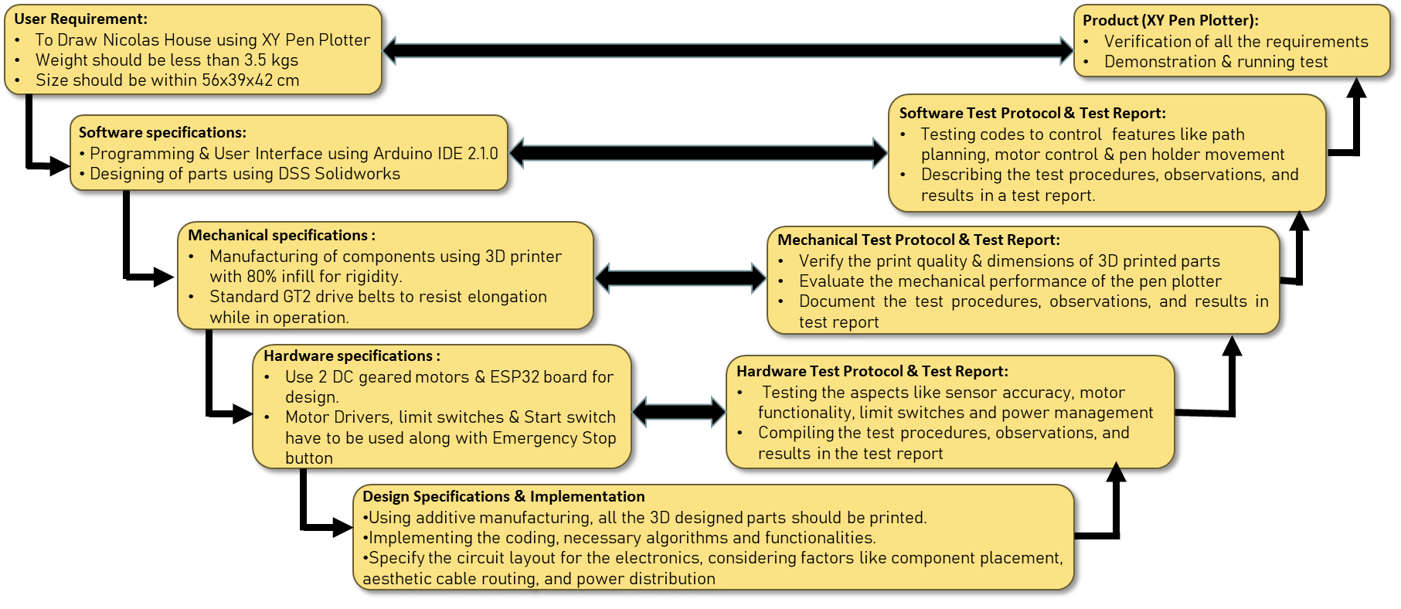

Figure 2.2 V-Model

The V-model of the pen plotter project provides a comprehensive framework for its development, ensuring a systematic and structured approach. The project begins with the User Requirement stage, where the specific needs and expectations of the users are gathered and documented. This information forms the foundation for the subsequent stages. The Technical Specification stage focuses on defining the detailed specifications of the pen plotter system, considering aspects such as size, resolution, speed, and accuracy. The Software Requirements stage identifies and documents the necessary software functionalities, user interface design, and programming requirements. The Mechanical Requirements stage specifies the mechanical components, materials, and design considerations, ensuring the robustness and functionality of the pen plotter's physical structure. The Electrical Requirements stage involves determining the electrical components, circuitry, and power requirements for the pen plotter.

The Implementation stage encompasses building the pen plotter system, including the assembly of mechanical and electrical components, integration of control systems, and software development. In the System Integration stage, the individual subsystems are combined and tested to ensure proper interaction and functionality. The Verification of Design stage involves rigorous testing and evaluation to ensure that the pen plotter design meets the specified requirements. System Testing is conducted to validate the overall performance, functionality, and reliability of the pen plotter under various conditions. The Test Report documents the results and findings from the system testing phase, including any issues encountered and their resolutions.

Finally, the completed and tested product, the XY Pen Plotter, is ready for deployment and use.

By following the V-model, the pen plotter project ensures a systematic and thorough approach to its development, resulting in a reliable and high-quality pen plotter system.

## Morphological Chart:

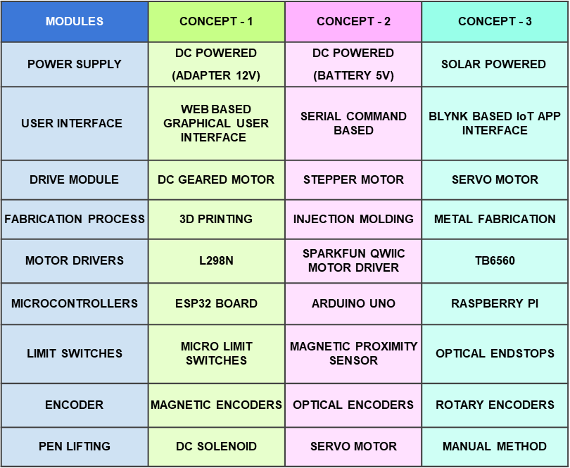

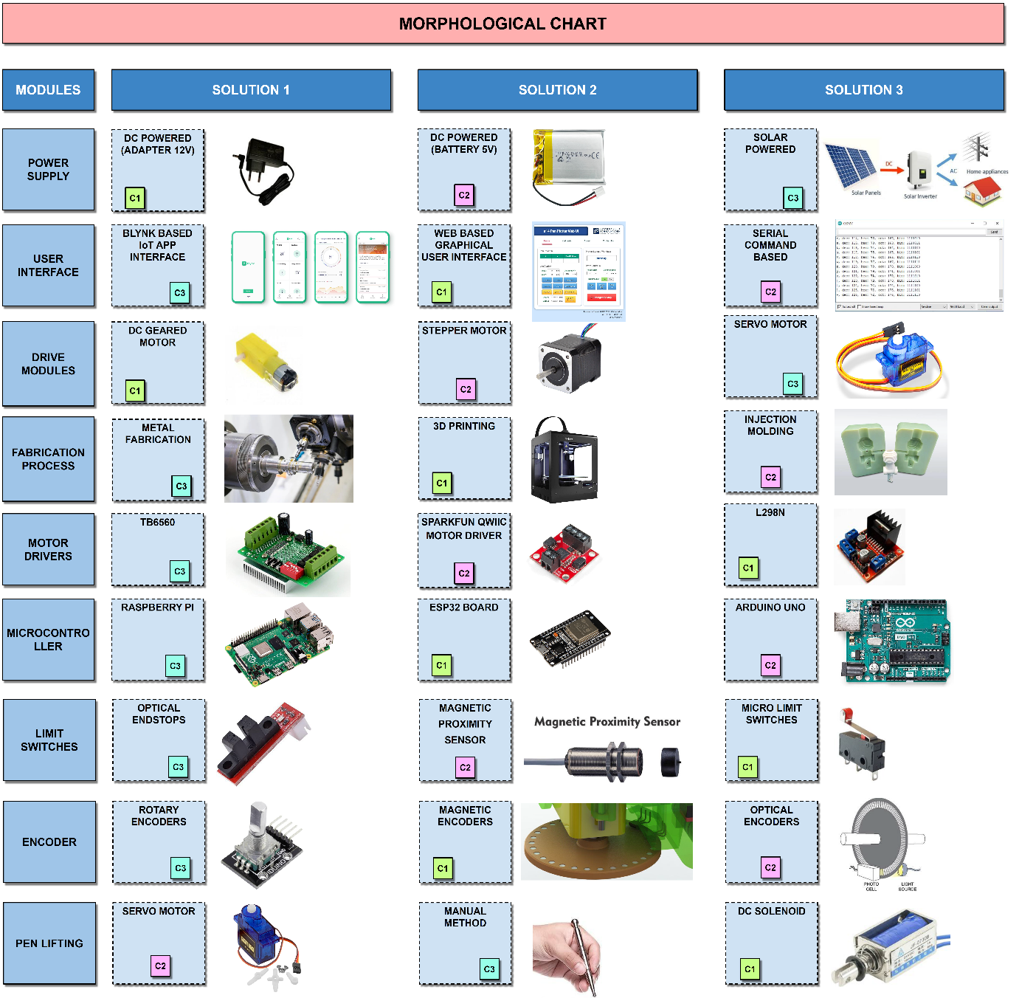

Figure 2.3 Morphological Chart

The morphological chart for the pen plotter project is a visual tool that presents various design options and their corresponding features. It helps in systematically exploring and selecting components such as motors, controllers, sensors, pens, and user interface elements, enabling informed decision-making for the pen plotter's design and functionality.

## Pairwise Comparison And Decision Matrix

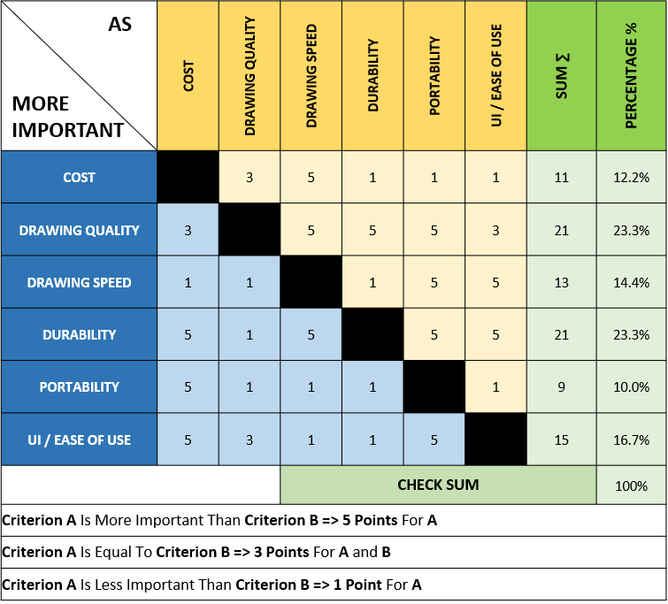To determine the winning pen plotter design concept from the three concepts resulting from the morphological chart, pairwise comparison and decision matrix techniques were employed.

Firstly, a set of criteria was established, such as accuracy, speed, cost, reliability, and ease of use. These criteria were essential in evaluating the design concepts.

With pairwise comparison, each design concept was systematically compared against the others based on the identified criteria. A relative preference or value was assigned to each concept for each criterion. By comparing all possible pairs of concepts, a comprehensive assessment was made.

Next, a decision matrix was constructed. The identified criteria were listed as columns, and each design concept was listed as rows. Weights were assigned to each criterion based on its relative importance. Then, each concept was evaluated against each criterion, and scores were given based on its performance. The scores were multiplied by the respective weights and summed up to obtain a total score for each concept.

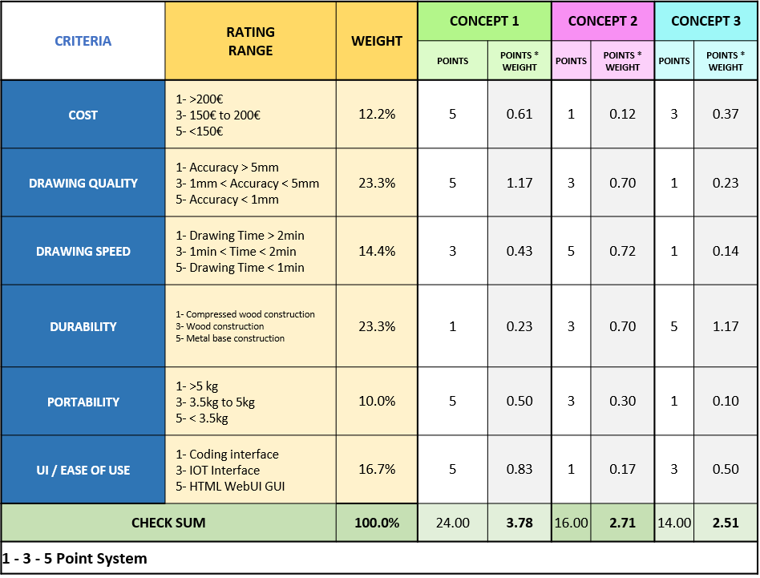Finally, by analysing the total scores, the concept with the highest score was determined as the winning pen plotter design concept. This systematic approach ensured an objective evaluation and facilitated the selection of the most suitable design concept based on the specified criteria.

# Design Stage

## Component Selection

1. D.C. Motor: Two DC motors are used in pen plotter project precise, rotary motion for controlling pen movement, enabling accurate plotting and drawing on various surfaces.

Figure 3.1 D.C. Motor

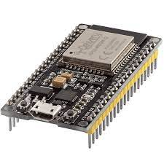

1. **ESP32 Board:** ESP32 board used in pen plotter project versatile microcontroller with built-in Wi-Fi and Bluetooth, providing wireless connectivity and control for precise pen plotting and automation.

Figure 4.2 ESP32 Board

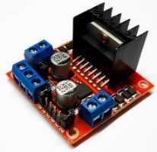

1. **L298N Motor Driver:** L298N Motor Driver used in pen plotter project dual H-bridge module controlling motor speed and direction, enabling precise movement and positioning of the pen in the plotter.

Figure 3.3 L298N Motor Driver

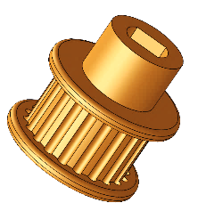

1. **Pulley:** Pulley used in pen plotter project mechanical component with grooves, facilitating smooth and controlled rotation of belts or cables for accurate pen positioning and movement.

Figure 3.4 Pulley

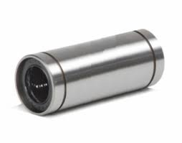

1. **Linear Ball Bearings:** Linear ball bearings used in pen plotter project rolling element bearings providing smooth and low-friction linear motion, ensuring precise and stable movement of the plotter carriage along the rails.

Figure 3.5 Linear Ball Bearing

1. 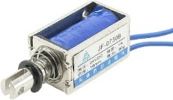**DC Solenoid Electromagnet:** DC solenoid electromagnet used in pen plotter project generates magnetic field when energized, controlling pen up/down movement for precise plotting and drawing on the paper surface.

Figure 3.6 DC Solenoid

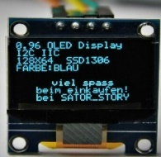

1. **OLED Display:** OLED display used in pen plotter project compact, high-resolution screen for real-time visualization of plotter status, settings, and feedback, enhancing user interface and control.

Figure 3.7 OLED Display

1. 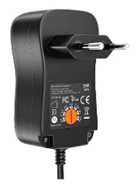**Adapter 12V (DC Power):** 12V DC Adapter used in pen plotter project provides regulated power supply to the plotter system, ensuring stable and reliable operation of the components and motors.

Figure 3.8 Adapter

1. **GT2 Driver Belt:** GT2 driver belt used in pen plotter project high-quality toothed belt for precise and synchronized movement, transferring rotational motion to linear motion with minimal backlash.

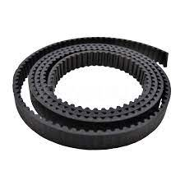

Figure 3.9 GT2 Belt

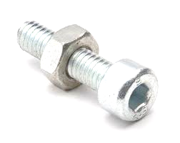

Figure 3.10 Fastener

1. **Screws and Fasteners:** Screws and fasteners used in pen plotter project securely fasten components, ensuring structural integrity and precise alignment for stable and accurate operation of the plotter system.

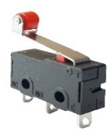

1. **Micro Limit Switch:** Micro Limit Switch used in pen plotter project small, mechanical switch with precise actuation, providing accurate end stop detection for pen movement control and positioning accuracy.

Figure 3.11 Limit Switch

1. 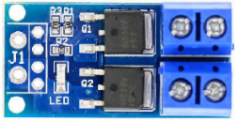 **MOSFET Switch:** MOSFET Switch used in pen plotter project electronic switch with high switching speed and low power dissipation, enabling efficient control of motor and other high-current devices in the plotter system.

Figure 3.12 MOSFET Switch

1. **49E Hall Sensor:** 49E Hall sensor used in pen plotter project magnetic field sensor detecting changes in magnetic field intensity, providing feedback for precise position sensing and control in the plotter system.

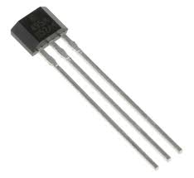

Figure 3.13 Hall Sensor

1. **DC-DC Voltage Converter:** DC-DC voltage converter used in pen plotter project converts input voltage to desired output voltage, providing power flexibility and stability for various components in the plotter system.

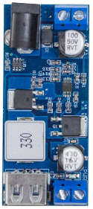

Figure 3.14   
DC-DC Voltage Converter

1. **Push Button:** Push button (kill switch) used in pen plotter project emergency stop button for immediate system shutdown, ensuring operator safety and preventing potential accidents during operation.

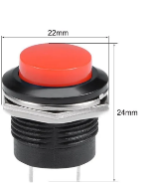

Figure 3.15 Kill Switch

## Electrical Design

Figure 3.16 Electric Circuit Diagram

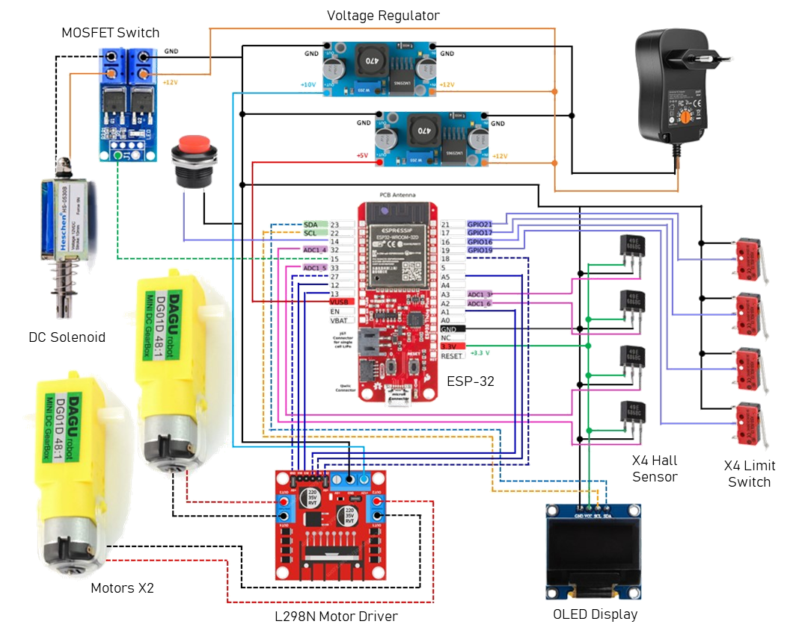

The electrical schematic diagram showcases the circuit configuration of a pen plotter project, demonstrating a well-structured and efficient design. The key components are carefully interconnected to ensure accurate and controlled plotting operations.

The core of the circuit revolves around the ESP32 microcontroller, serving as the main controller, controlling X & Y axis motors independently using L298N motor driver. The motor driver allows precise control over the motor speed and direction, enabling smooth and accurate movement of the pen plotter. This configuration ensures that precise drawings can be achieved.

To control the vertical motion of the pen, a 12V DC solenoid with a force of 5N is incorporated. The solenoid acts as a mechanism to raise or lower the pen onto the plotting surface. By selectively activating the solenoid through the microcontroller, the pen can be precisely positioned for drawing or lifted to avoid any unintended marks.

To provide visual feedback and display the operational status of the plotter, a 0.96-inch OLED display is integrated into the circuit. This display offers a clear and concise interface to convey information such as the current progress of a drawing, error messages, or user prompts. It enhances the user experience by providing real-time updates and facilitating interaction with the plotter.

The circuit also incorporates four Hall sensors as encoders to provide precise position feedback. These sensors detect and measure magnetic fields, allowing the microcontroller to accurately determine the pen's position on the plotting surface. This feedback loop ensures precise and reliable plotting, enabling the creation of intricate and well-defined designs.

To establish boundaries in the X-Y plane and prevent any potential damage, limit switches are strategically positioned. These switches act as end stops, halting the movement of the pen plotter when it reaches predefined limits. By triggering the microcontroller upon activation, the limit switches provide an added layer of safety and prevent the plotter from exceeding its designated working area.

In contrast to using a breadboard, the circuit is constructed using a perf-board. This choice eliminates the risk of signal noise caused by loose connections, ensuring a reliable and stable operation of the pen plotter. The perf-board provides a secure and organized platform for assembling the components, contributing to the overall robustness of the system.

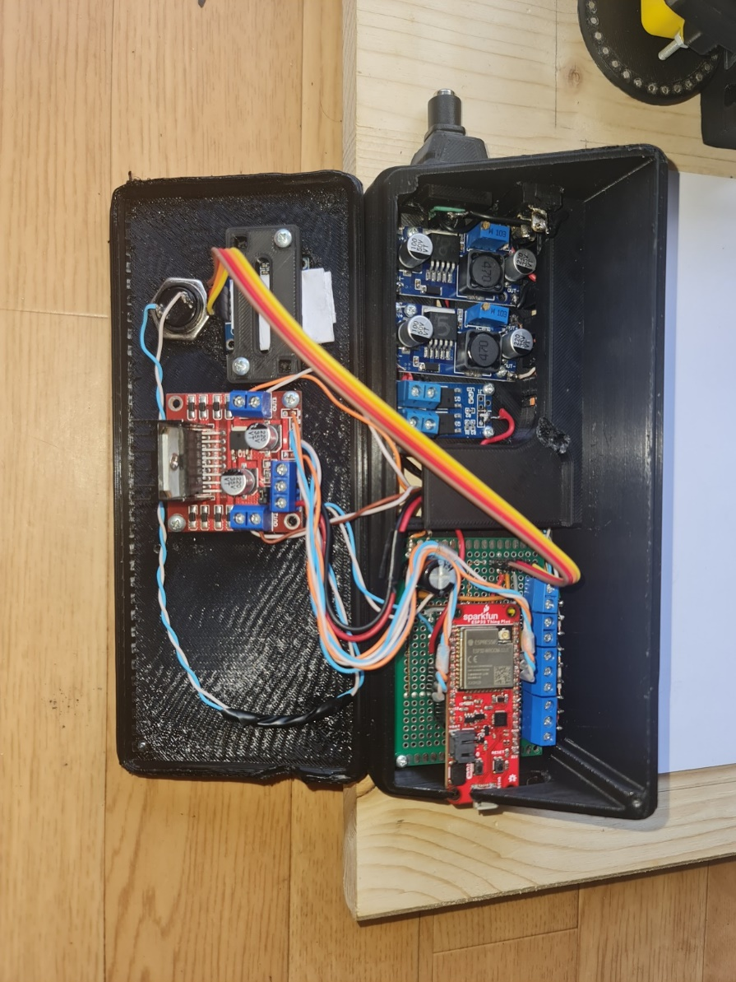

In summary, the electrical schematic diagram presents a comprehensive circuit configuration for a pen plotter project. Through the effective integration of the L298 motor driver, ESP32 microcontroller, DC solenoid, OLED display, Hall sensors, limit switches, and perf-board construction, the circuit enables precise control, accurate plotting, and improved reliability, ultimately facilitating the creation of intricate and high-quality drawings.

## Mechanical CAD Design

As per requirements, the planning phase regarding the design was done and the below procedure was followed:

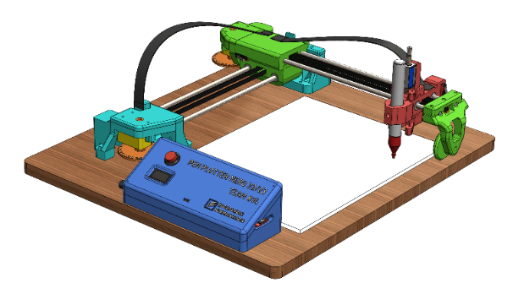

Figure 3.17 CAD Design

Initially, the following components were designed accurately by using DSS SolidWorks:

a) Frame and Structure

b) Carriage and Slides

c) Pulley and its fixtures

d) Pen Holder

**NOTE:** Standard components like DC geared motor, ESP32 microcontroller board, L298N motor driver, 0.96” OLED display, DC solenoid 5N, etc. were downloaded and dimensions were verified with those of physical components.

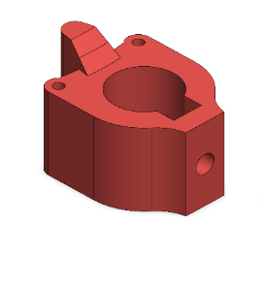

Figure 3.18 Pen Holder

1. **Pen holder:** It is a mechanical component designed to securely hold the pen, enabling controlled and precise movement during plotting. It accommodates different pen sizes, allows for quick pen changes, and ensures consistent pen pressure for accurate and smooth drawings.
2. **Shaft Guiding Block:** It is a sturdy component that supports and guides the shaft, ensuring smooth and precise linear motion of the pen plotter carriage along the rails. It reduces friction, minimizes vibrations, and enhances the overall stability of the system for accurate plotting.

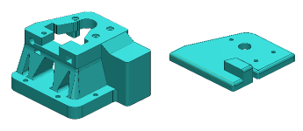

Figure 3.19 Shaft Guiding Block

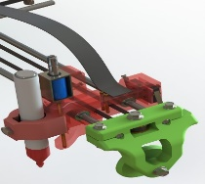

1. **Wheel supporting assembly:** The wheel supporting assembly in a pen plotter project is a crucial component that provides support to the cantilever X-axis. It consists of a rotating wheel mechanism that helps guide the movement of the pen plotter along the X-axis rail. The assembly ensures smooth and stable motion, reducing friction and vibrations for precise plotting and drawing.

Figure 3.20 Wheel supporting assembly

1. **Base Plate:** The base plate in a pen plotter project serves as the foundational chassis on which the entire assembly is mounted. Typically made of wood, it provides stability and support to the various components, ensuring a rigid structure for accurate and reliable pen plotting operations.

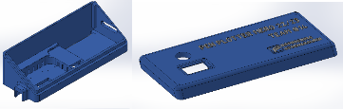

Figure 3.21 Control Interface Block

1. **Control Interface Block:** The control interface block in a pen plotter project is a specially designed 3D printed block that serves as a housing for electrical wirings, buttons, and the controller chip.

It provides a convenient and organized arrangement, securing and protecting these components, simplifying the wiring connections, and facilitating easy access for control and operation of the pen plotter system.

## Key Design Decision

Decisions related to design play a crucial role in shaping the user experience of the Pen Plotter. Choosing the right components, materials, and mechanisms ensures that the Pen Plotter performs its intended tasks effectively and efficiently. By making user-centric design decisions, the Pen plotter can be more user-friendly, aesthetically pleasing and enjoyable to operate. Following are the optimal design choices made by our team.

1. **Position of limit switch for better wiring:** The fixtures were made considering the wiring network of Limit switches, preventing localized wire dispersal and unsightly visibility.

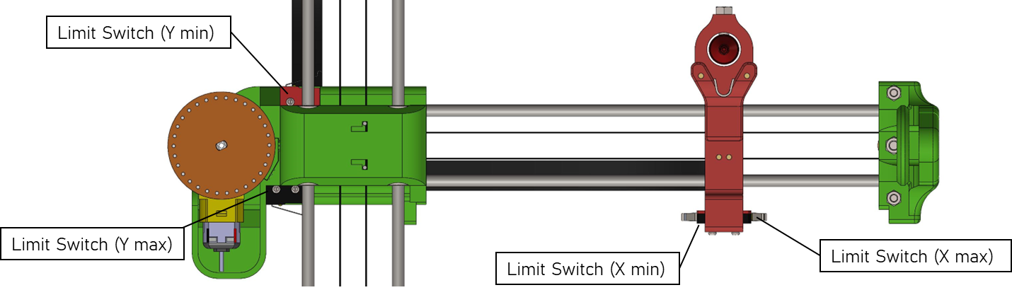

1. **Use of Display Screen:**  We have used 0.96inch OLED display to following features:

* Welcome Screen
* Web server initialization & local IP
* Home Screen with XY Position & Status of Pen plotter:   
  Jogging/ Calibrating/ Idle/ Plotting
* Warning Screen: Displays the status of all limit switches
* E-Stop active screen with instructions.

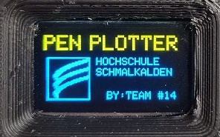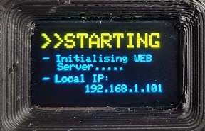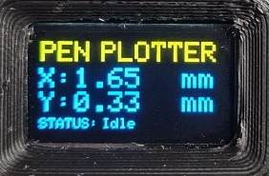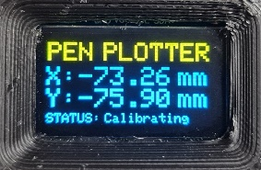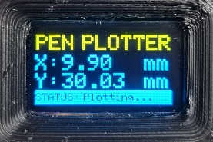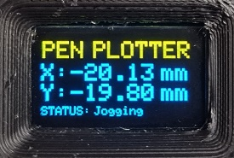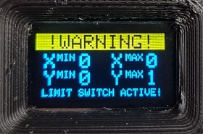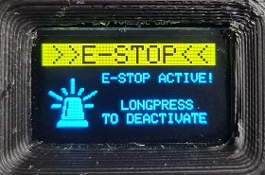

**1**

**2**

**3.1**

**3.2**

**3.3**

**3.4**

**4**

**5**

Figure 3.22 OLED Display

1. **Design of magnetic encoder disc:**

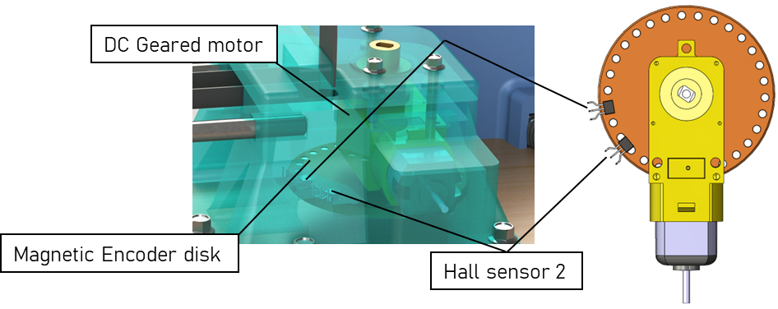In a pen plotter project, a magnetic encoder system is implemented to convert the rotational motion of DC geared motors into precise linear movements in the XY plane. Hall sensors detect changes in the magnetic field, providing feedback for accurate position sensing, enabling precise pen plotting and drawing on the paper surface.

Figure 3.23 Magnetic Encoder Disc

1. **Enclosure for Electronic circuitry:**

In the pen plotter project, an enclosure is created to conceal the wiring network and electronic circuit components. The enclosure features an OLED display for real-time visualization, an Emergency Stop button for immediate system shutdown, and an ON/OFF switch for easy power control. This housing ensures a clean and organized appearance while providing convenient access to essential controls.

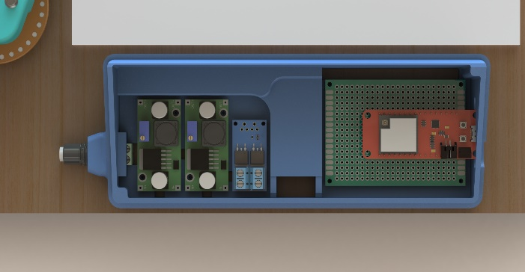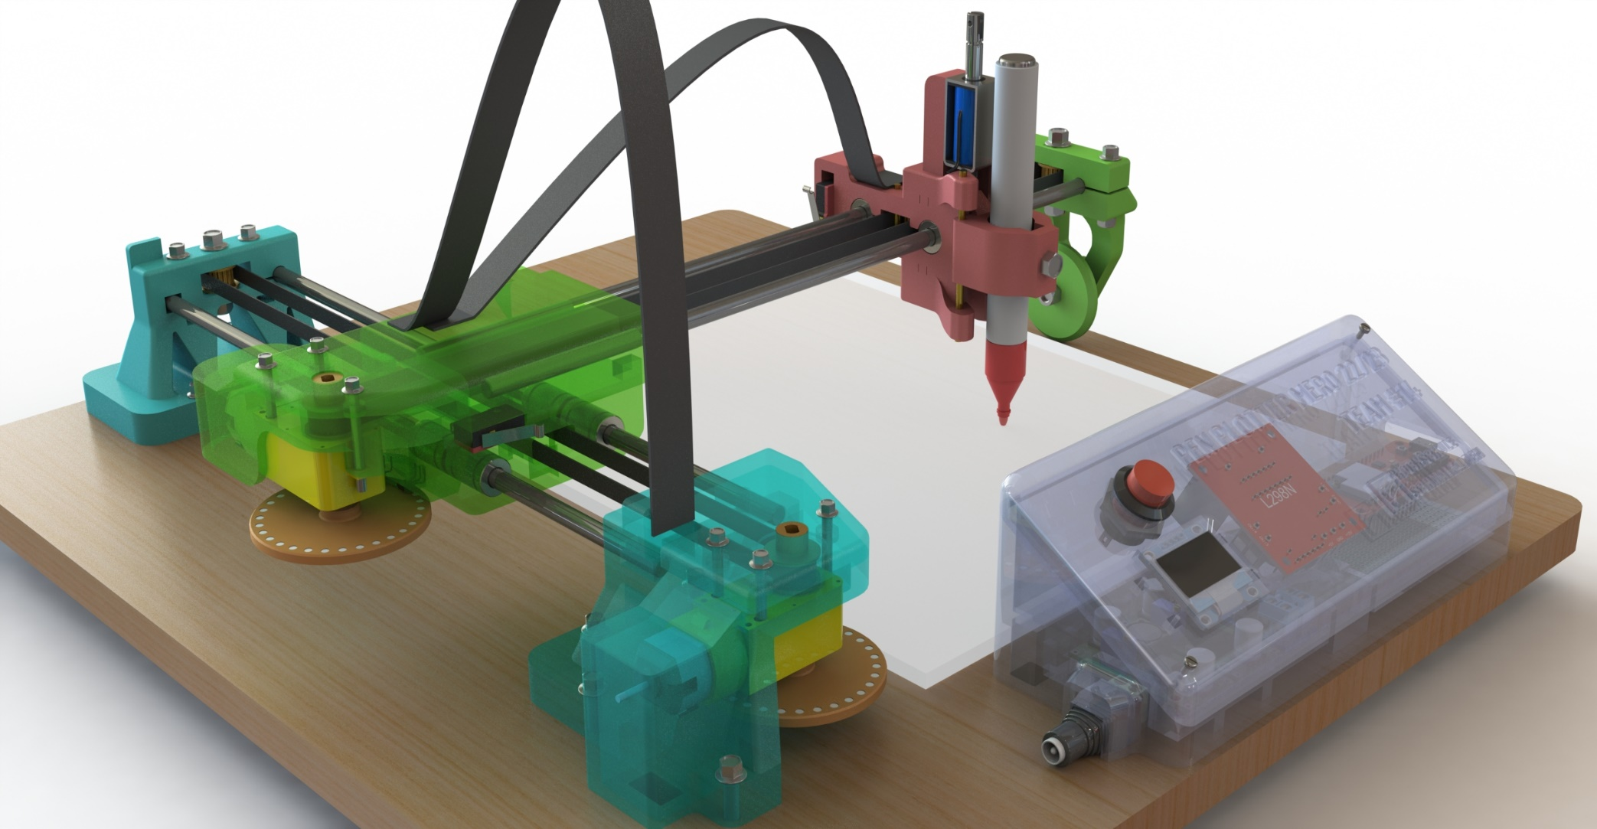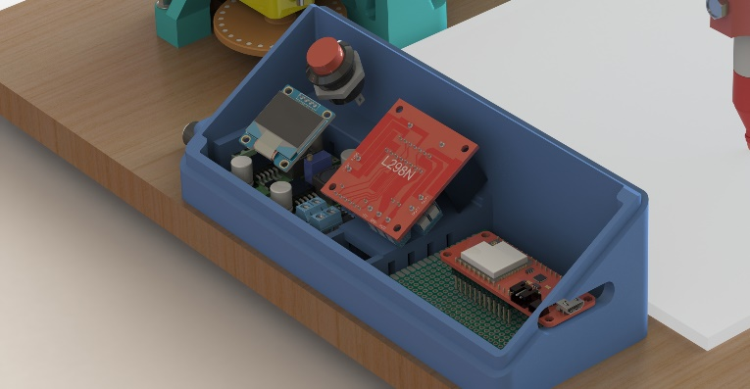

1. **Graphical User Interface and its features:** Using HTML code, we have designed a web user interface which has the following features:

* Control the movements of pen carriage in XY plane
* Placing the carriage in the drawing area at the specified X, Y coordinates as well as the home location (X=0, Y=0).
* Decision making regarding House width, start position (Point 1 or point 2 of the Nikolaus Haus).
* Raising or lowering the pen against the drawing surface.
* The status of specific Limit Switches changes to “ “when the X or Y carriage slides at the extreme boundaries of the XY plane, and the Webpage blinks yellow.
* Either click the "Emergency button" on the webpage or hold down the "red button" on the Circuitry enclosure for 2 seconds to entirely stop the plotter's activity. This results in a red-blinking website.

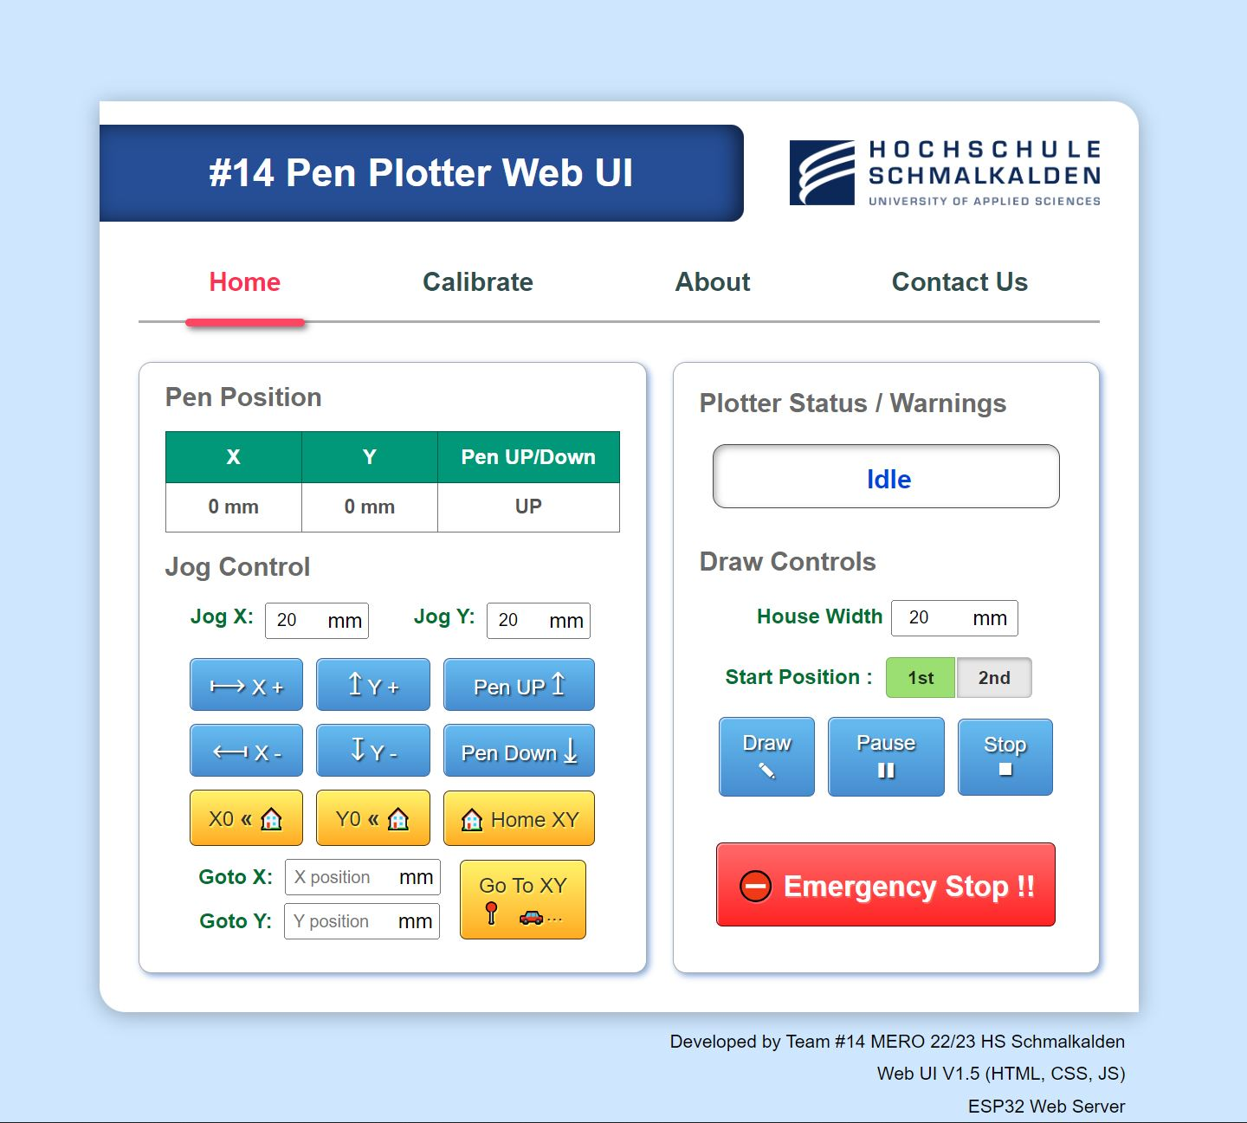

Figure 3.24 Pen Plotter Web UI

# Development and Fabrication Stage

## Process used to develop the pen plotter

The development and fabrication stage of the pen plotter involves transforming the initial concept into a fully functional device. This includes designing the mechanical structure, selecting and integrating components, fabricating and assembling the physical components, testing the system for functionality and accuracy, and documenting the process for future reference and improvement.

## Selection of materials

In the common FDM printing process, PLA (Polylactic Acid) is the perfect entry-level filament and can be easily processed by any standard 3D printer. PLA has been chosen for due to:

* 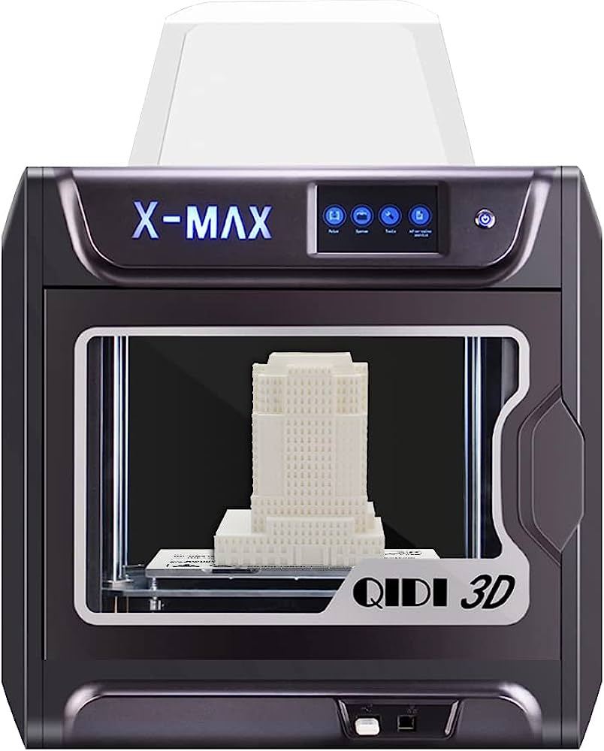Good printability
* Lower distortion (warping) during printing.
* Ease of use
* Affordability, and
* Compatibility with 3D printing technology
* Eco-friendliness
* All the 3D designed components were printed in “QIDI TECH X-MAX 3D Printer” available in the AKT lab, Haus D

Figure 4.1 3D Printer

## Use of Test Piece

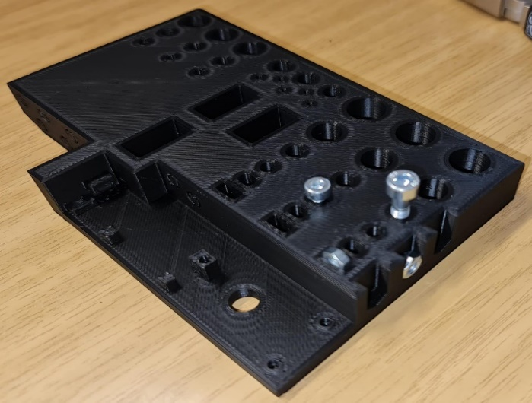 The use of a test piece in 3D printing allows for evaluating print quality, identifying potential issues, and optimizing printing parameters for correct tolerance and fitment before producing the final parts. It helps ensure accuracy, functionality, and compatibility, minimizing errors and reducing material and time wastage.

Figure 5.2 Test piece

## Challenges faced during Development Stage:

**Issues related Wire routing:**

In electronic design, one of the crucial tasks is concealing the wiring network to enhance the visual appeal of the product. Exposed wires not only create a cluttered and unattractive appearance but also undermine the overall design and professionalism of the product. Moreover, the vulnerability of exposed wires to snagging, bending, or accidental tampering can lead to electrical malfunctions or even complete failure of the device. To address these concerns, we have developed an enclosure with an inbuilt wire routing channel that effectively houses all the wiring connections and electronic components. The inclusion of plastic cable ribbons facilitates the routing of wires to the X and Y carriages, ensuring a clean and organized internal structure for improved functionality and reliability.

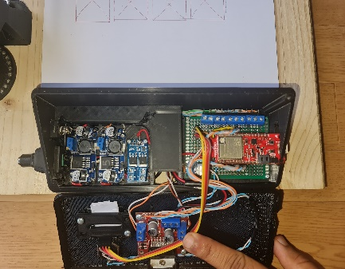

Figure 4.3 Wires and Cables

**Problem related to Noise in Sensor output signals:**

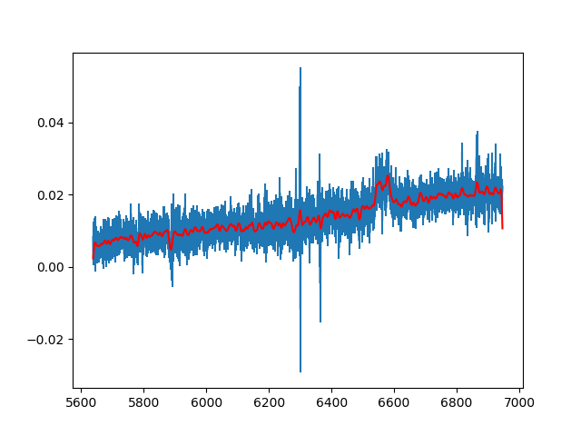In our design, we have incorporated Hall sensors along with a magnetic encoder disk to detect changes in the magnetic field during rotation. The magnetic encoder disk comprises alternating magnetic poles arranged at equal intervals around its circumference. As the magnetic poles pass by the Hall sensors, they induce voltage due to the Hall effect, enabling position and movement interpretation by microcontrollers. However, the presence of noise in the sensor output signals resulted in inconsistencies in position sensing, leading to inaccurate plotting and deviations from the intended plot path. To address this issue, we employed proper wiring techniques, such as twisted pair cables, to minimize ground loops and reduce noise coupling. Additionally, the implementation of a digital Butterworth filter, a signal filtering technique, significantly reduced high-frequency noise components. Furthermore, we shielded all the wires using a Silver-Plated Copper Braid to protect the sensor signals from external electromagnetic interference, ensuring more reliable and accurate performance.

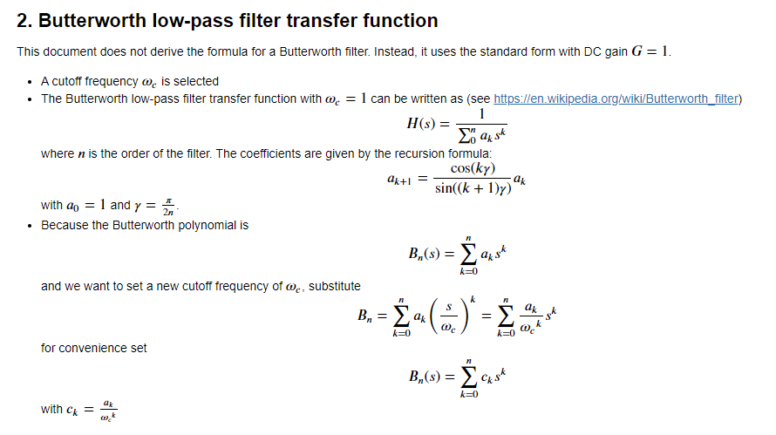

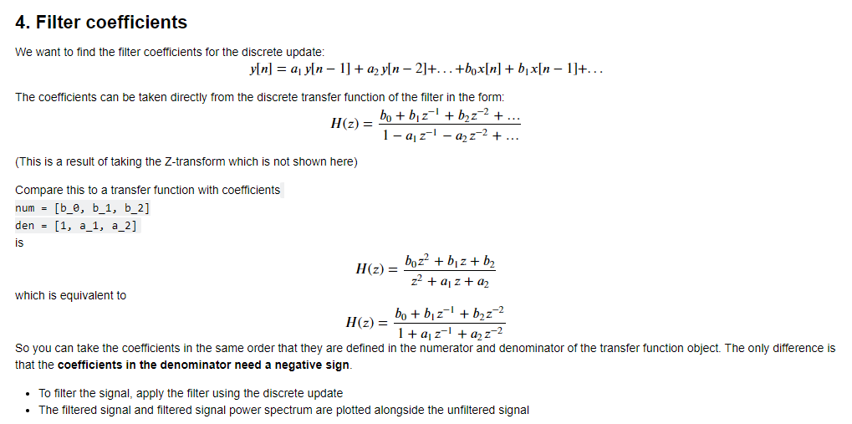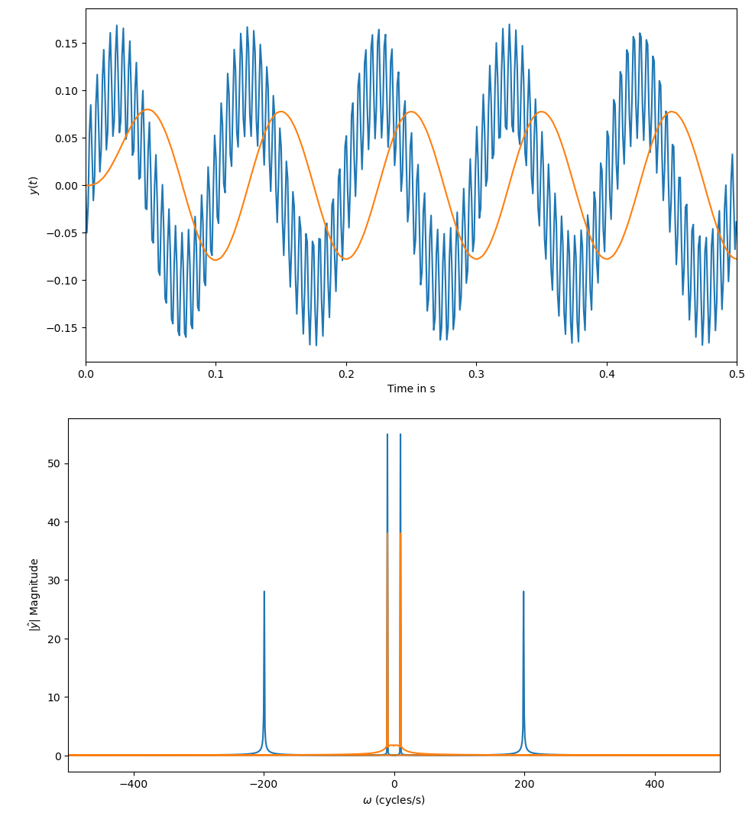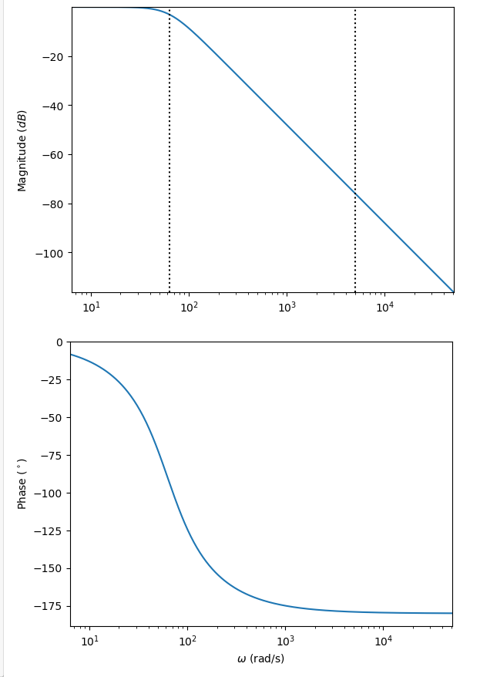

# Testing and Iteration

The testing and iteration stage in building a pen plotter project involves thoroughly evaluating the system's functionality, performance, and reliability. This includes testing motion control, pen actuation, and plotter coordination, identifying any issues or limitations, and making iterative refinements to optimize the project's overall performance and accuracy.

## Testing Procedure:

* **Limited Color Range**:

Pen plotters typically utilize one color of pen or marker, which limits the usage of color in the artwork to monochrome or a small range of colors. With just pen plotters, it might be difficult to create color combinations that are lively and varied.

* **Slow Speed**:

In comparison to other printing technologies, pen plotters work at comparatively slower speeds. Their effectiveness for large-scale or time-sensitive tasks is constrained by the mechanical nature of the device and the accuracy needed for accurate charting, which can lead to lengthier processing and plotting periods.

* **Positional accuracy**:

Pen plotters may work with DC geared motor as well as Stepper motor. However, with micro-stepping, stepper motors offer superior positional accuracy over dc geared motors.

* **Limited Media Compatibility**:

Pencil plotters function best on flat materials like paper or cardstock. When attempting to plot on unusual or uneven terrain, they could run into problems. The limited media compatibility might prevent experimentation with and examination of various artistic mediums.

## Design Iteration:

The CAD design of the pen plotter project incorporates carefully designed cable routing paths to ensure efficient cable management and minimize potential cable entanglement or obstruction during operation. The aim is to maintain a clean and organized layout while facilitating smooth movement of the plotter. By strategically planning cable routes, potential issues such as cable interference with moving parts, signal interference, and overall system reliability are addressed. Attention is given to factors like cable length, flexibility, and secure attachment points to ensure optimal performance and minimize the risk of cable-related malfunctions. The design considerations emphasize the importance of cable management to maintain a streamlined and efficient operation of the pen plotter.

# Conclusion and Acknowledgements

In conclusion, our pen plotter project has successfully come to fruition, showcasing the seamless integration of a diverse range of components. The project has been a testament to our team's dedication, expertise, and collaborative effort. The utilization of key components such as DC motors, an ESP32 board for efficient control, a DC-DC converter for optimized power management, a Hall sensor and encoder for precise positioning, a linear ball bearing for smooth pen movement, pulleys for accurate belt drive, a DC solenoid for pen lifting, an OLED display for intuitive user interaction, and micro limit switches for reliable end stop detection has resulted in a high-performing and user-friendly pen plotter.

We extend our heartfelt gratitude to all those who have contributed to the success of this project. Our appreciation goes to the team members who worked diligently on every aspect, from design to implementation, ensuring the functionality and performance of the pen plotter. We would also like to acknowledge the support and guidance provided by our mentors and advisors, whose expertise has been invaluable throughout the project's development.

The successful completion of this pen plotter project opens up new possibilities in creative expression and design, and we look forward to further refining and expanding its capabilities in the future.

## Bill of Materials:



## Future Scope:

Pen plotters have a bright future with lots of room for innovation and growth. In order to create immersive and interactive artistic experiences: Use of higher-quality DC geared motors with finer gear ratios to achieve more accurate positioning and smoother movement. Working on the design and making it more reliable and efficient so that the vibrations can be reduced and quality of the drawing can be improved. Future designs might focus on reducing the size and weight of the plotter while maintaining its functionality and performance.

In addition to the points mentioned above, the future of pen plotters holds several possibilities for innovation and growth:

* Integration of AI and Machine Learning: By integrating artificial intelligence (AI) and machine learning algorithms, pen plotters can gain the ability to analyse and reproduce complex artistic styles or patterns. This would enable the creation of unique and customized drawings based on user preferences or learned artistic techniques.
* Multi-Colour and Mixed-media Capabilities: Expanding the capabilities of pen plotters to accommodate multiple colours or even different drawing mediums (such as pencils or markers) can open up new avenues for creativity and artistic expression.
* Collaborative Features: Developing collaborative features, allowing multiple pen plotters to work together on a single drawing or synchronized artwork, could facilitate group projects, interactive installations, or even live art performances.

Overall, the future of pen plotters is bright, with the potential for advancements in accuracy, connectivity, control systems, AI integration, and collaborative capabilities, promising immersive and interactive artistic experiences for users.